Harry Potter, Physics, and Invisibility
Worksheet
Motivation: As a keen physics student re-watching the Harry Potter series. You start to think: Maybe I can make an invisibility cloak myself? Wouldn’t it be convenient to be invisible from time to time?
Aim: Using our current knowledge of physics, we hope to breakdown and interpret the problem of invisibility as a physics problem.

Part 1: Defining the terms
What is invisibility?
Fill in the blanks
Invisibility is the state of an object that _____________ be seen or detected
_____________ is another word for invisibility.
A _____________ is the technology used to achieve invisibility of an object.
When we successfully cloak, we should not be able to _____________ the _____________ or the object.

Part 2: Defining the problem
The eye can be thought of an __________ problem.
_____________ is the physics of light.
Then, invisibility can be also be thought of as an _____________ problem.

Part 3: Reviewing our physics
Match the letters to the definitions
- Reflection
- Refraction
- Lens
- Normal
____ when light bends after passing through media with different index of refraction
____ a medium that allows light to pass to either concentrate or disperse
____ redirecting light in the opposite direction
____ is a reference line that is 90 ͦ to the surface
Label the diagram
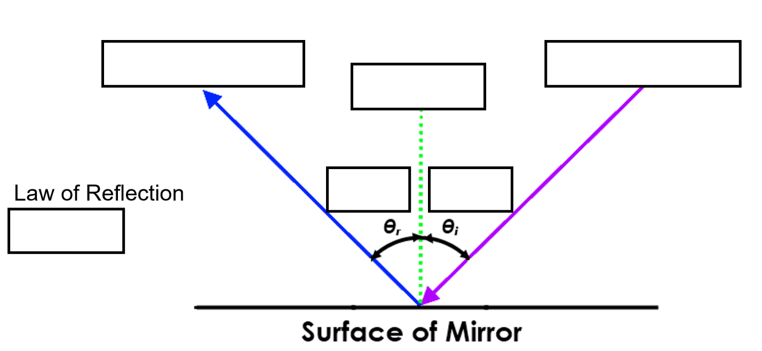
Part 4: Attempting cloaking with reflection
Watch my demonstration and answer the following:
What do you see in front of you?

How does the apparatus work?

How many mirrors do you think is used in my apparatus?

Part 5: Self-reflection and Discussion
Critical thinking
Did we achieve invisibility? Why or why not?

What changes would you make and what would you do differently?

