Ferrofluid and Magnetism Demonstration Worksheet Name: __________________

Answer the following questions as we encounter them: Date: _________________

1. When the magnet is attracted to the metal surface, is the surface also a magnet? Why or why not?

2. Draw the fields of these 4 dipole configurations (single, 2 parallel, 2 opposite each other), and rank
their field strengths from strongest to weakest.

Remember: Lines go from any north to any south pole, they prefer to spread out, and they must not cross! Use four field lines per bar.

A single dipole | 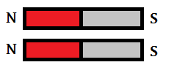  2 parallel dipoles
2 opposing (anti-parallel) dipoles  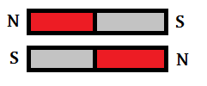 | 2 dipoles one way, and a 3rd dipole the other way  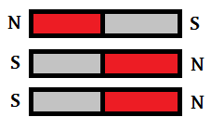

3. According to the principle of minimum energy, how would two dipoles prefer to be arranged? How
about 4? Draw the lowest possible energy configuration for each:

2 Dipoles at minimum energy: 4 Dipoles at minimum energy:

4. Can we make a ferromagnetic fluid out of dissolved iron atoms or liquid iron? Why or why not? Can you propose of another way of making a magnetic fluid?

5. Given the shapes of the field for each experiment, and that ferrofluid wants to find the areas of highest field density (flux), predict for each experiment how the fluid will react. Give a reason why you might see what you do!

After the experiment is done, sketch what you saw. Suggest a reason why the fluid behaved this way.

Experiment 1: Magnet beneath the fluid

Prediction: | Observation:

Experiment 2: Magnetized Screw

Prediction: | Observation:

Experiment 3: Strong field above fluid

Prediction: | Observation:

